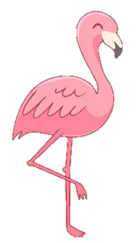
Welcome to Year 2 Flamingos Class!
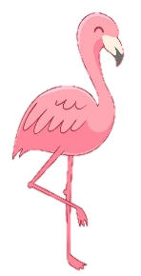
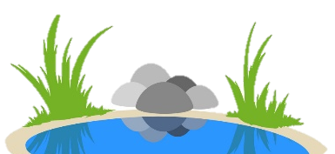
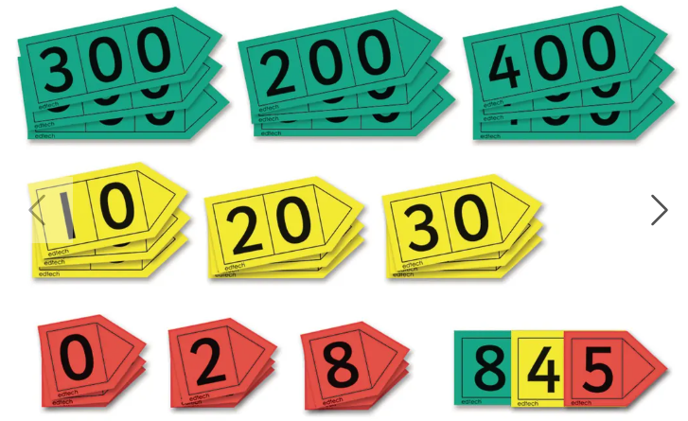
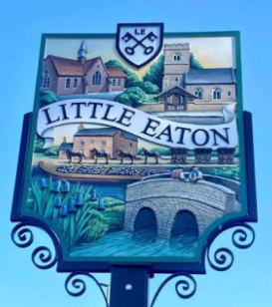
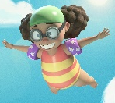


The Year 2 team and I hope that you enjoyed a wonderful summer and were able to spend some quality time together as families in the beautiful weather. We are looking forward to welcoming the children back to a new year of exciting learning! Here is some information to assist as we transition into Year 2 including subject coverage and general information. The adults working with Flamingos class will be myself, Miss Warren and Mrs Askew. We are also delighted to welcome Mrs Mould to the team as the children step into the outdoors for their first experience of Forest School! Any further updates will be sent through Tapestry or text message.
Quizzes
Children will have weekly quizzes on Fridays which will focus on spelling patterns, following our phonics scheme.
We will also complete maths recall quizzes, beginning with addition and subtraction.
English
Our first story of the year will be based on the clip ‘Bellyflop’.
Children will familiarise themselves with events of the story,
character descriptions, and the journey the main character, Penny,
goes on as she attempts to perform a trick from the highest diving board!

Children can flex their writing skills, refamiliarize with the basics of writing, grammar and punctuation through a humorous clip with a happy ending!
Reading
Children will be bringing home books to read daily, and we kindly ask that you comment on your child’s reading to share how your child engages with reading. Encouraging discussion regarding books aims to give children a love of reading that will support them through life and children who read for around 10 minutes a day nurture this love for reading.
Reading diaries will be sent to and from school daily so that reading at home and in school can be
recorded. We also ask that you read to
your children to help them develop a
pleasure for reading and love of books.

Book change will be on Monday for all children.
Phonics
Children will learn new phonics sounds as well as exploring grammar patterns such as suffixes.
Focus sounds and patterns for this half term are:
- y as ‘igh’
- dge/ge as ‘j’
- gn as ‘n’
- kn as ‘n’
- wr as ‘r’
- -es suffix (words ending with y)
- -ing/ -ed suffix (words ending with y
Topic
Our topic this half term will focus on fieldwork and locational knowledge.
We will learn about using maps to find locations and routes, symbols on maps and what they represent, the features of a map, compasses to assist with directions, use these directions to describe movement,
fieldwork and data collection
including drawings, labels and
simple charts.

Maths
In maths we will begin our learning with Place Value to 100.
This will include counting numbers to 100 by using tens and ones, recognising tens and ones, using place value charts, partitioning numbers to 100, estimating numbers to 100 on a number line, comparing numbers to 100,
ordering numbers to 100, and
counting in 2s, 5s, 10s and 3s.
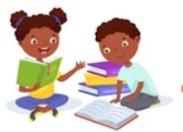
Across the Curriculum

Science: Animals Including Humans. Children will sort and group animals and their young, make observations about life cycles, study stages of the human life cycle, gather information about the survival needs of humans and animals, and consider how to stay healthy.
Art and Design: Sensational Salads. Children will explore existing products of salads, consider a balanced diet including food groups, learn where the fish we eat comes from, learn how to use a knife safely, make and evaluate a salad.
Music: Learning Through Singing Games. Children will focus on pitch and identify high and low sounds in the songs they sing. Movement will help children explore pulses and duration of sounds, recognise rhythmic patterns and build musical foundations.
PSHE: Relationships. Children will explore who their important people are and why they are special, why families are important, what makes a good friend, how to manage fallings out and resolve disagreements, how to work together effectively, how to show care and why this is important. For more information on the PSHE covered this half term, please see the Overview on the class page.
RE: Islam. Children will explore ideas about Muslim beliefs about Allah, including the 99 Names of Allah, learn about the life of the Prophet Muhammed, recognise objects used by Muslims and why they are important, and explore Ramadan and Eid-ul-Fitr as religious festivals.
Computing: Networks. Children will explore what a computer is by identifying inputs and outputs, and how computers process information.
Other Information
Please can all uniform and drinks bottles be named.
Please can children bring a waterproof and/or winter coat during the colder months as we will be outside throughout the year.
Please continue to use the school logo book bag for ease of storage.

If you have any questions, please do not hesitate to reach If you have any questions, please do not hesitate to reach out through Mrs Carter in the office who can forward messages to me, in person after school, or through Tapestry.
Homework
A homework folder will be sent home on Mondays with one sheet of maths and one sheet of spelling and grammar to support your child’s learning.
Homework is due in on
Fridays to allow marking
and assessment.

PE
Please ensure your child has a full PE kit in school with named items including a white T-shirt or polo top, jumper or fleece, navy or black shorts or games skirt, tracksuit bottoms or leggings, plimsolls and trainers. It is preferable if PE kits are kept in a drawstring bag for ease of storage.
For health and safety purposes, we ask that any hair longer than shoulder length be tied up for any PE event, and that no jewellery is worn during sporting activities.

This half term, we will be taking part in orienteering and rounders.
Forest School
We are fortunate to have the opportunity to attend Forest School in Year 2 with Mrs Mould. This will take place across the year on a Wednesday afternoon.

A letter will be sent home
on Tuesday 8th September
with information about all
things Forest School!
Any queries or information to pass on can be done so via the school office - Julie.carter@littleeaton.derbyshire.sch.uk or 01332 831471 – or directly with myself at the end of the school day.
Thank you for your support, Miss Gascoyne and the Year 2 Team.

