Fold mountains

- The tectonic plates crash into each other.
- The pressure causes them to fold together and push up.
- This happens over a long period of time.
- These are the most common mountains

Fault-block mountains

- A fault-block mountain is formed when a crack appears in the Earth’s crust.
- A plate breaks into a block.
- Some parts rise up, others sink down.
- As they move apart, blocks of rock end up being stacked on one another.

Volcanic mountains

- Volcanic mountains are formed when molten rock (magma) erupts, and piles upon the surface.
- When the ash and lava cools, it builds a cone of rock.
- Rock and lava pile up, layer on top of layer.

Dome mountains

- Dome Mountains are the result of melted rock (magma) pushing its way up under the earth crust.
- Without actually erupting onto the surface, the magma pushes up overlaying rock layers.
- When it cools it forms a dome shape.

Plateau Mountains

- Plateau Mountains are formed when water erodes the land around it (erosion)
- They are formed next to large cliffs.
- They leave deep valleys next to the cliffs.

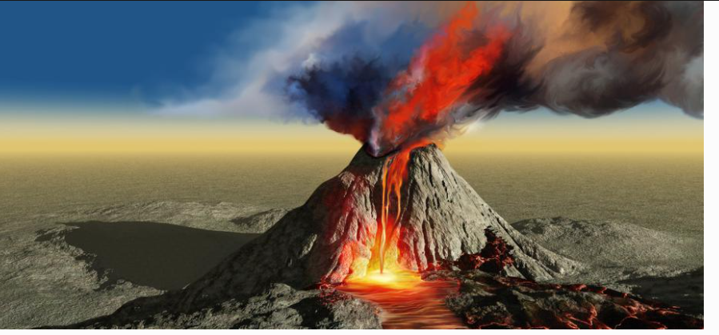
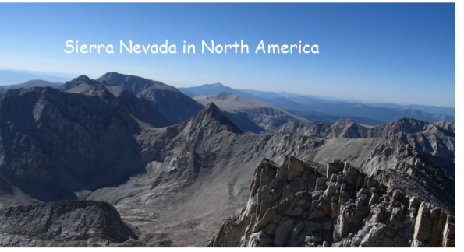
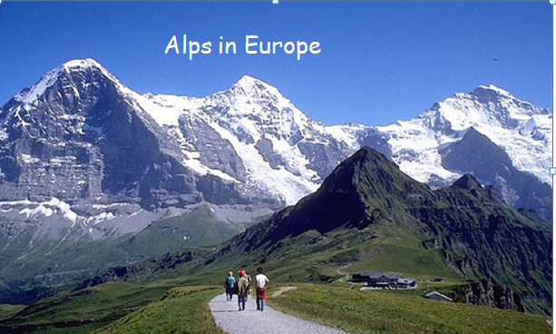
St Vincent, Caribbean


