  Little Eaton Primary School. | EYFS Policy 2024.

At Little Eaton we provide a high-quality EYFS education giving children a secure and confident start to their school life. We are committed to nurturing a lifelong love of learning alongside the aims of the EYFS statutory framework. We strive for high standards, consider the development of the whole child and seek to foster resilience and independence.
At Little Eaton School we aim to provide a creative curriculum that allows for many ‘I Wonder’ moments as the children engage in many real-life opportunities within an immersive environment. We aim to ensure children are ready to move on to the national curriculum.
We provide inviting classroom environments indoors and outdoors to stimulate learners and engage them in developing the three ‘Characteristics of Effective Learning’ as set out within the EYFS.
When we give every child the best start in their early years, we give them what they need today. We also set them up with every chance of success tomorrow. Development Matters [DfE, 2021]

Intentions:
We carefully plan our EYFS curriculum to meet the following aims:
- Foster a love of learning which inspires curiosity.
- Provide experiences of awe and wonder; promoting a love of learning through real life experiences and opportunities to build on prior learning.
- Ensure all children have access to high quality learning opportunities.
- Provide parents/carers with the opportunity to develop their child’s learning at home.
- Develop knowledge and understanding of the community and wider world.
- Provide stimulating learning environments indoors and outdoors, using a well-planned continuous provision allowing the children to learn through play.

Implementation:
Staffing & Organisation
At, we have one Reception class which caters for 30 children.
EYFS class teacher and lead: Mrs M Simmons
EYFS class teaching assistant: Mrs A Mosley
Children come to our school from a range of local pre-school settings and nurseries.

- The EYFS statutory framework does not prescribe a particular teaching approach.
- “Play is essential for children’s development, building their confidence as they learn to explore, relate to others, set their own goals and solve problems. Children learn by leading their own play, and by taking part in play which is guided by adults.” Where is this quote from?
- In our classroom, you may see children playing alone or with their peers, deciding on resources and choosing how to spend their time. You may see a child playing and listening to an adult, who is modelling how to achieve something or teaching a new skill that interests the child.
- Adults may scaffold a child’s play. This involves taking their play to higher levels of learning, entering the play as a co-creator and helping to provoke a framework for the children to go from “what they know” to “what else they could know”. Scaffolding enables a child to solve a problem, carry out a task or achieve a goal which is just beyond his or her abilities. During play, where foundational social and emotional skills are developed, scaffolding is a bridge to new skill levels using three key ingredients; modelling the skill, giving clues and asking questions while the child is trying out a new skill, and then as the child approaches mastery, withdrawing the support.
- As the children develop and their skills progress throughout the reception year, we use more direct teaching and modelling and plan specific sequences of lessons. These strategies help us to focus on teaching the essential skills and knowledge in the specific areas of learning so that the children can develop the skills and confidence required for the end of their reception year.

EYFS Statutory Framework
Characteristics of Effective Learning describe behaviours children use in order to learn. To learn well, children must approach opportunities with curiosity, energy and enthusiasm. Effective learning must be meaningful to a child, so that they are able to use what they have learned and apply it in new situations. These abilities and attitudes of strong learners will support them to learn well and make good progress in all the Areas of Learning and Development.
The three characteristics of effective teaching and learning are:
• Playing and exploring – children investigate and experience things, and ‘have a go’.
• Active learning – children concentrate and keep on trying if they encounter difficulties, and enjoy achievements.
• Creating and thinking critically – children have and develop their own ideas, make links between ideas, and develop strategies for doing things.

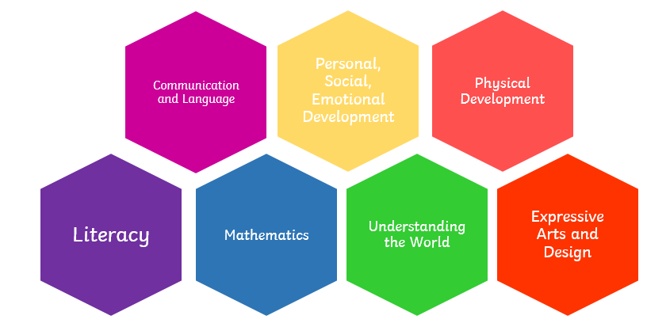

The Curriculum
- At Little Eaton, the EYFS lead carefully plans what the children learn in the classroom and through provision enables them to learn from their interests, alongside extending their knowledge and understanding through direct teaching.
- Each day, we stimulate children’s interests, respond to each child’s emerging needs and guide their development through warm, positive interactions coupled with secure routines for play and learning.
- We ensure planning helps every child to develop their language skills.
- The curriculum is ambitious. Careful sequencing will help children to build their learning over time.
- Planning is flexible to ensure children’s interests are used to drive the children’s learning and development.
- We ensure that depth in early learning is achieved through spending time embedding the children’s learning.

Assessment
- Assessments are completed to inform planning and support the practitioners in identifying children who need additional support.
- Assessment is based upon a secure knowledge of child development.
- Practitioners have a clear expectation about what children need to know and how best to support them in developing their learning.
- Accurate assessment is used to highlight whether a child has a special educational need or needs extra help.
- Tapestry is used to record an electronic learning journey for each child. Tapestry is used as a valuable tool to assess children’s development and to provide a link for parents/carers.

Partnership with Parents
- We ensure that parents/carers have a strong and respectful partnership in the early years which enables children to thrive.
- We listen regularly to parents and give parents clear information about their children’s progress through face-to-face opportunities and electronically via Tapestry.
- Parents are encouraged to support their child’s learning and development at home as this has a significant impact on their child’s learning.
- We take the time to ‘get to know’ and understand the children and their families enabling us to offer support as needed. We carry out home visits before the children start school in September. This provides the foundation for strong and effective partnerships with parents.
- Parents/carers are invited into school for a ‘Stay and Play’ session with their child prior to starting school. This provides parents/carers with the opportunity to familiarise themselves with the classroom environment and meet other parents.
- Parents/carers are given the opportunity throughout the year to engage in the wider school community.
- Parents/carers are fully involved in their child’s learning and development through the use of Tapestry, which is regularly updated.
- Parent’s are invited into school for regular parents evenings to provide an update about their child’s learning and progress.
- Children with SEND or additional needs have in-depth ‘shared conversations’ to ensure targets and progress are shared.
- We are flexible in our approach to communicating with parents/carers and adapt our communication methods to suit different preferences.

Inclusion
- At children will be given an equal chance of success.
- We ensure that all children have access to high-quality early education. We pay particular attention to those children from disadvantaged backgrounds to ensure we can ‘narrow the gap’.
- We provide high-quality early education and care which is inclusive for all children. Children’s special educational needs and disabilities (SEND) are identified quickly. All children promptly receive any extra help they need, so they can progress well in their learning.

Impact:

- High levels of engagement and motivation demonstrated from children which supports them to become lifelong learners.
- Confident and capable readers who demonstrate a love of reading.
- Evidence of strong links with parents.
- Children demonstrate the characteristics of effective learning and are well prepared for the next stage in their learning.
- Children feel happy and safe and enjoy coming to school.
- All children access a balanced and challenging curriculum regardless of their background, needs or abilities.
- Children make strong progress from their starting points and are offered a broad curriculum which meets each child’s unique needs.
- Children are supported by adults that are well trained and passionate about providing the best education for every child.
- The percentage of children achieving the GLD within the EYFSP is in line with or above the national average.

Any questions or concerns regarding this policy should be made to Mrs. M Simmons (EYFS Lead)

------------------------------------------------------------------------------------------------------------------------------------
Confirmation that the policy for EFYS, in respect of Little Eaton Primary School, has been discussed, approved and ratified by the Governing Body:

Signed by:

Chair of Governors: ……………………………………………… Date: …………………………

Headteacher: ……………………………………………………….. Date: …………………………

Approved at the Governing Body Meeting on:

