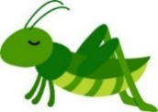
Welcome back Grasshoppers!
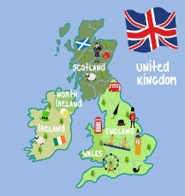
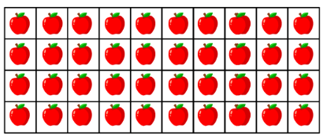
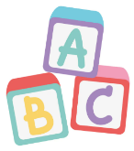
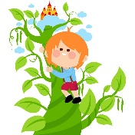

I hope you were able to enjoy a fun-filled Spring break and enjoyed the wonderful sunshine we were treated to. We are looking forward to a wonderful Summer term in Grasshoppers class with visits from giants, tennis lessons, and much more! This time of year is always lovely as the weather warms up and the children show great maturity in all they do. Here is an update of our learning over the next six weeks, alongside some useful information. Mrs Cowlishaw, Miss Warren, Mrs Askew and I will be working with you this half term. Any further updates will be sent through Tapestry or text message.
Spellings
Our weekly spellings will follow our phonic learning with a focus on ten words per week using the weekly spelling pattern.
Spelling sheets will be sent home on Fridays.
English
Our English this term will be delivered through Talk for Writing,
a wonderful way to explore stories, tell narratives and develop
independence in writing. Our two focus stories of the term are
Jack and the Beanstalk and The Tiny Seed.
We will use story maps to learn texts, consider how stories are told through a ‘mountain’ and continue to develop key features of writing
including the use of adjectives, .!?, narratives, and using capital letters for proper nouns.
Phonics
Phonics sounds we will learn this half term are:
-s / -es ing / er
-er / -est are / ear
tch unspoken /e/
Your child’s pink sound book now has all the sounds we will learn over the course of Year 1. If your child has not received new sounds, please send in your sound book and new sounds will be added.
This is a great resource to use whilst reading or writing with your child to encourage familiarity with these sounds.
Topic
Our topic this half term
will focus on the locational
knowledge of the United
Kingdom.

We will learn about urban and rural areas, the different nations of the UK, look at aerial maps of key features of the UK, discover the capital city of London, and compare London to another capital city – Brasilia.
Maths
In maths we will be learning about capacity and volume, introducing multiplication and division and fractions.
This will include building understanding of equal groups, counting in 2s, 5s and 10s, making arrays, doubling, recognising and finding halves and quarters of shapes, objects and amounts.
Reading
Children will be bringing home books to read daily, and we kindly ask that you comment on your child’s reading to share how your child engages with reading. Encouraging discussion regarding books aims to give children a love of reading that will support them through life and children who read for around 10 minutes a day nurture this love for reading.
Reading diaries will be sent to and from school daily so that reading at home and in school can be
recorded. We also ask that you read to
your children to help them develop a
pleasure for reading and love of books.

Book change will be on Friday for all children.
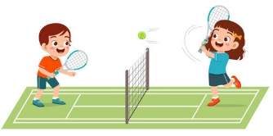
If you have any questions, please reach out through Mrs Carter in the office who can forward messages to me, in person after school or through Tapestry.
Other Information
Please can all uniform and drinks bottles be named.
Please can children bring a waterproof and/or winter coat during the colder months as we will be outside throughout the term.
Please continue to use the school logo book bag for ease of storage.
Supporting Learning at Home
Children will continue to have a Homework Folder.
On Fridays, children will bring home a phonics activity and a maths activity related to their learning. This is a great opportunity to support their learning and is designed so that it can be completed independently or supported.
New sheets will be sent home each Friday. If you are struggling in any way, please do not hesitate to reach out.
Across the Curriculum

Science: Plants. Children will learn about observing plants, labelling plants, garden and wild plants, and fruits and vegetables.
Art and Design: Sculpture. Children will study a range of artists and take inspiration to sculpt people, animals and objects with a range of materials.
Music: Children will be learning a new song ‘Round and Round’ and will continue to develop skills of rhythm and musical understanding.
PSHE: It’s My Body. Children will learn about making healthy choices for their bodies, the importance of sleep and exercise, making healthy choices about food and drink, the importance of personal hygiene, what is safe and unsafe to eat and drink, and how to keep the mind and body healthy.
RE: Caring for Others. Children will learn about how Christians, Muslims, Jews and Humanists approach caring for others, objects and the environment.
Computing: Programming. Children will use BeeBots to explore how computer programmes respond to commands and how to programme a device accurately.

PE
Please ensure your child has a full PE kit in school with named items including a white T-shirt or polo top, jumper or fleece, navy or black shorts or games skirt, tracksuit bottoms or leggings, plimsolls and trainers. It is preferable if PE kits are kept in a drawstring bag for ease of storage.
For health and safety purposes, we ask that any hair longer than shoulder length be tied up for any PE event, and that no jewellery is worn during sporting activities.

This half term we are pleased to resume our PE sessions with our sports coach
Mr Samuel on Thursdays, as well as head off to the Little Eaton Tennis Courts
to take part in tennis coaching sessions on Tuesdays.
Any queries or information to pass on can be done so via the school office - Julie.carter@littleeaton.derbyshire.sch.uk or 01332 831471 – or directly with myself at the end of the school day.
Thank you for your continued support, Miss Gascoyne and the Year 1 Team

