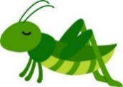
Happy New Year Grasshoppers!
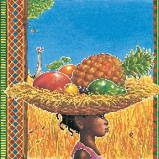

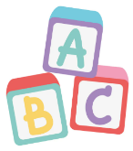

I hope that your break over the holidays was filled with fun and festivities as well as a well-earned rest! As we move forwards to the Spring term, here is an update of our learning over the next six weeks, alongside some useful information. Mrs Askew, Miss Warren, Mrs Ridgway and I are happy to welcome you back to Year 1 and cannot wait to see you in the new year. Any further updates will be sent through Tapestry or text message.
Spellings
Our weekly spellings will follow our phonic learning with a focus on ten words per week using the weekly spelling pattern.
Spelling sheets will be sent home on Fridays.
English
Drawing Club remains the base of our English
learning as we read a new story each week. Children
will be encouraged to explore key features of writing
including the use of adjectives, and the building of
narratives.
Our first story will be Handa’s Surprise, a wonderful story allowing the children to practice descriptive writing, all with a super twist!
Phonics
Phonics sounds we will learn this half term are:
ue aw/au
ew ow/oe
-y wh
Your child’s pink sound book will be updated to include these sounds, if your child has not received new sounds, please send in your sound book and new sounds will be added.
This is a great resource to use whilst reading or writing with your child to encourage familiarity with these sounds.
Topic
Our topic this half term
will focus on the
geography of Kenya
within Africa.

We will learn about where Kenya is on a world map, including map skills, the wildlife of Kenya, human and physical features within Kenya, the Massai tribe, and consider how life differs in different geographical locations.
Maths
In maths we will be learning about Place Value and Addition and Subtraction Within 20.
This will include building understanding of teen numbers, working with number lines to answer addition and subtraction questions, estimation and comparison of numbers within 20, number bonds to 20, doubles and near doubles.
Reading
Children will be bringing home books to read daily, and we kindly ask that you comment on your child’s reading to share how your child engages with reading. Encouraging discussion regarding books aims to give children a love of reading that will support them through life and children who read for around 10 minutes a day nurture this love for reading.
Reading diaries will be sent to and from school daily so that reading at home and in school can be
recorded. We also ask that you read to
your children to help them develop a
pleasure for reading and love of books.

Book change will be on Friday for all children.
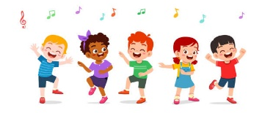
Other Information
Please can all uniform and drinks bottles be named.
Please can children bring a waterproof and/or winter coat during the colder months as we will be outside throughout the term.
Please continue to use the school logo book bag for ease of storage.
Supporting Learning at Home
Children now have a Homework Folder.
On Fridays, children will bring home a phonics activity and a maths activity related to their learning. This is a great opportunity to support their learning and is designed so that it can be completed independently or supported.
New sheets will be sent home each Friday. If you are struggling in any way, please do not hesitate to reach out.
Across the Curriculum

Science: Animals including humans. Children will learn about animal groups, animal diets, distinguishing features, and why humans are mammals.
Art and Design: African Collage. We will study the artist Brianna McCarthy and be inspired to make collages using a range of mediums to create colourful and creative works.
Music: Children will be learning a new song ‘Rhythm in the Way You Walk’ and will continue to develop skills of rhythm and musical understanding.
PSHE: TEAM. Children will learn about how working as a team can benefit everyone, the importance of listening and kindess, what to do if someone is unkind to them, how to be a positive learner and the difference between good and not-so-good choices.
RE: Christianity. Children will learn basic beliefs about Christianity, how Christians see God and ways in which Christians express worship.
Computing: Programming. Children are introduced to programming and will begin to understand language regarding programming as well as using basic commands on the computer.
PE
Please ensure your child has a full PE kit in school with named items including a white T-shirt or polo top, jumper or fleece, navy or black shorts or games skirt, tracksuit bottoms or leggings, plimsolls and trainers. This will ensure that no matter the weather, our PE lessons will be comfortable. It is preferable if PE kits are kept in a drawstring bag for ease of storage.
For health and safety purposes, we ask that any hair longer than shoulder length be tied up for any PE event, and that no jewellery is worn during sporting activities.

Our PE topic this half term is dance and we will explore different music, dance styles and free expressive movement.
on endurance and perseverance as we build fitness skills.
If you have any questions, please reach out through Mrs Carter in the office who can forward messages to me, in person after school or through Tapestry.
Any queries or information to pass on can be done so via the school office - Julie.carter@littleeaton.derbyshire.sch.uk or 01332 831471 – or directly with myself at the end of the school day.
Thank you for your continued support, Miss Gascoyne

