A Bizarre Beast
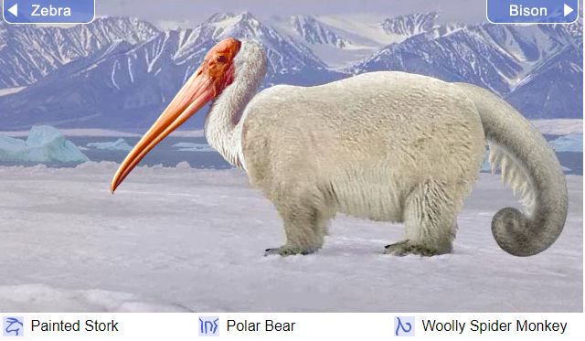
Have you ever seen an amazing creature like this?

Explorer Nick Day, first discovered this species in the Arctic in December 2017. After several years of study, he named the unique and unusual creature a stopokey (a combination of the animals it reminded him of: a stork, a polar bear and a spider monkey.) Since then, occasional sightings of this fascinating creature have been reported. If you want to know more about this bizarre beast, then read on!

Appearance:
Stopokeys are rare to see, but easily identified. Its most distinguishing feature is a long, pink beak that can measure up to 1m in length. With highly camouflaged white fur, they are able to blend into the snowy conditions of their habitat as soon as their beak is hidden. Adult stopokeys have a thick, furry coat which provides insulation against the minus 70º temperature. Young stopokeys (known as a stopoki) have a shorter, thinner coat and during the winter months stay in its mother’s pouch (a secure pocket similar to a kangaroo). Amazingly, a stopokeys tail is the same length as its body and can be used to kill a predator with a single swipe.
Fascinating facts

- When they are first born, a stopoki has no fur and spends most of its time in its mothers’ pouch. It takes 10 years for the fur to be fully grown.
- A stopoki can survive without eating for between 3-6 months.
- Strangely, a stopoki only needs to excrete waste once every month.

Habitat:
Most stopokeys can be found in small dens located in the thick ice of the Arctic. They generally use their sharp beak to dig out ice chambers which they use to shelter from the cold winter weather. Interestingly, a young stopoki will remain in the shelter for 10 years so that their thick fur can grow before they venture out.

Diet:
Stopokeys are carnivores and mainly eat small birds, rodents or fish. Like many other Arctic mammals, a stopokey will eat snow every day and doesn’t ever need to drink liquid.

Unusually, a stopokey will eat their prey whole (including the bones and skin). Typically, they will regurgitate the bones they cannot digest as a pellet several hours later which they bury deep in the snow.

As a diurnal animal, they hunt for food during the day and sleep during the night. This is because they have poor eyesight and struggle to see in the darker conditions. Instead, they have a very strong sense of smell and hearing which allows them to track and kill prey.

Under threat:
Although these magnificent creatures have only recently been discovered, it is believed they are already classified as critically endangered. Frighteningly, scientists wonder how long this winter warrior can survive as the ice of the Arctic is shrinking.

Features to find:

Topic sentence (sentence to introduce the paragraph)
Generalisers (many, few, occasional, mainly etc)
Adverb start (often ‘ly’ ending)
Technical / scientific language
Extra information in brackets

