Bizarre Beast – habitat and facts
Challenges:
- Topic sentence
- Generalisers
- Alliteration

Vocabulary collection: You can ‘magpie’ my ideas or create some of your own
Habitats | Generalisers | Alliteration
Continents  Asia, North America, South America, Europe, Oceania, Africa  Country (eg)  United States, France, Australia, Egypt, Madagascar etc  Habitats:  desert, rainforest, grasslands, savannah, ocean, woodland, wetlands, mountain  Home:  Cave, nest, pond, burrow, hedgerow, river, den, shelter | most  many  some  the majority  unusually / usually  often  occasionally  generally  normally  a few  all | Facts:  - Fantastic  - Fun  - Fabulous  - Fascinating  Information:  - Interesting  - Intriguing  - Incredible  Statistics:  - Strange  - Super  - Stupendous  - Spectacular

My Model:
Most stopokeys can be found in small dens located in the thick ice of the Arctic. They generally use their sharp beak to hollow out ice chambers which they use to shelter from the extremely cold winter weather. Interestingly, a young stopoki will remain in the shelter for 10 years whilst their thick fur develops before they venture out.

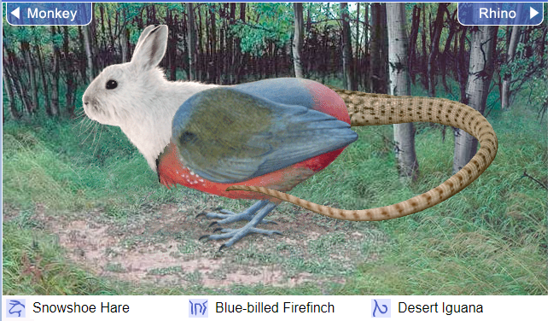

Snowfinch iguana’s can now be found in most continents of the world. Generally, they prefer to live in nests that they build in the high canopy trees of the rainforest to escape from its many predators. Interestingly, a young snowfinch iguana will usually leave its parents to build construct its own home after only 7 days.
Intriguing information

- A snowfinch iguana can detach its tail if being chased by a predator. A new tail will grow back within a month.
- Strangely, a snowfinch iguana prefers to eat lying on its back.
- The majority of snowfinch iguanas are able to sleep standing up, but can only dream when lying down.

