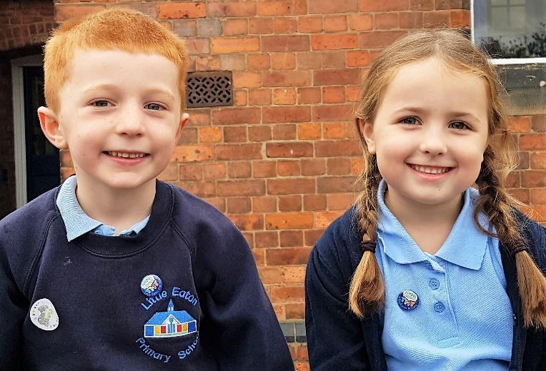
Welcome to
Little Eaton School

